SIMATS ENGINEERING
ASSESSMENT TOOL 1 – COMPLETED ASSIGNMENT
COURSE NAME: INTERNET PROGRAMMING | COURSE CODE: CSA43

COURSE OUTCOME COVERED
CO-1: Develop well-structured, standards-compliant web pages using HTML/XHTML and XML, and apply Internet protocols and HTTP communication mechanisms for web content delivery (L2).
Assessment Tool: Application-Based Questions
Weightage: 40%
Total Marks: 30

Student Name: N. Sai Preethika Register Number: 192372344

1. Online Symposium Portal
Scenario: A college is developing an online symposium registration portal. The given form collects a student's name and email address and submits the information to the server using POST.
1. Identify appropriate HTML5 semantic elements missing in the structure.
The form can be placed within a <main> element because registration is the page's primary content. A <header> can contain the page title and introductory information, while a <section> can group the symposium registration content under a descriptive heading. A <footer> may contain contact details or copyright information. These elements describe the purpose of each region and improve document structure; they should be used where appropriate rather than added without meaningful content.
2. Modify the structure to make it standards-compliant.
The revised form below includes the HTML5 doctype, language, character encoding, viewport metadata, semantic page regions, associated labels, required fields, and an explicit submit button. The server must also validate submitted values.
<!DOCTYPE html>
<html lang="en">
<head>
<meta charset="UTF-8">
<meta name="viewport" content="width=device-width, initial-scale=1.0">
<title>Symposium Registration</title>
</head>
<body>
<header>
<h1>College Symposium Registration</h1>
</header>

<main>
<section aria-labelledby="registration-heading">
<h2 id="registration-heading">Register for the Symposium</h2>
<form action="/register" method="post">
<label for="name">Full name:</label>
<input type="text" id="name" name="name" required>

<label for="email">Email address:</label>
<input type="email" id="email" name="email" required>

<button type="submit">Submit Registration</button>
</form>
</section>
</main>

<footer>
<p>For assistance, contact the symposium organizers.</p>
</footer>
</body>
</html>

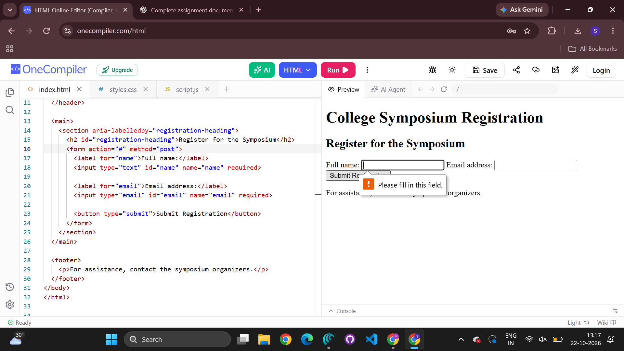
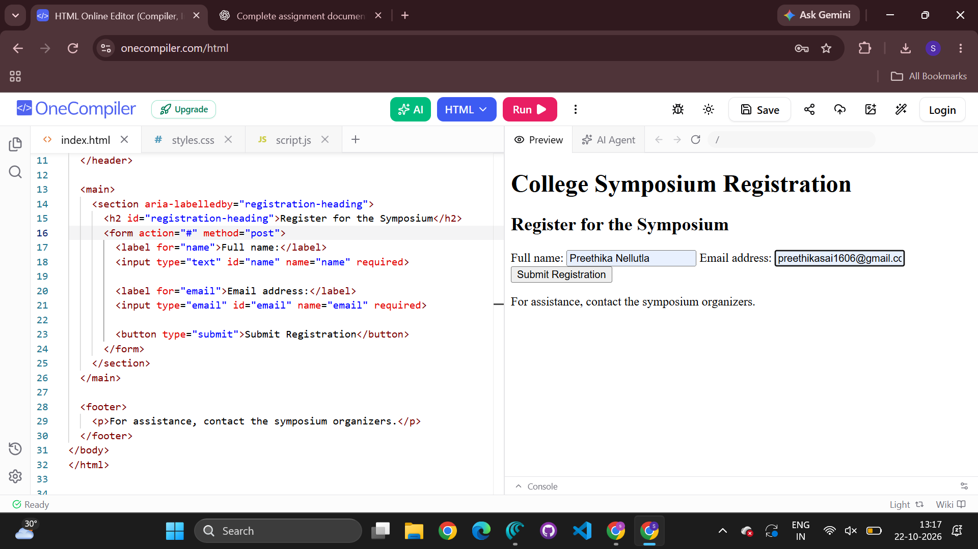
3. Interpret the HTTP request generated during form submission.
When the student submits the form, the browser sends an HTTP POST request to the relative path /register on the current origin. The request includes headers such as Host, Content-Type, and Content-Length as appropriate. With a standard HTML form using method="post" and the default encoding, the form fields are usually sent in the request body as application/x-www-form-urlencoded data, for example name=Anu&email=anu%40example.com. The exact headers depend on the browser and connection. POST places the form data in the body rather than in the URL query string, but it does not by itself encrypt the data; HTTPS is required for transport encryption.
4. Analyze the HTTP response cycle from server to browser.
The server receives the POST request, parses the submitted fields, validates the input, and performs the required registration operation. It then returns an HTTP response containing a status code, response headers, and usually a response body. A successful registration may return 201 Created or redirect the browser to a confirmation page using a 303 See Other response. Invalid input may produce 400 Bad Request or a page explaining validation errors; server failures may produce a 5xx status. The browser interprets the status and headers, follows a redirect if instructed, and renders the returned HTML or other content. The response should clearly communicate success or failure.
5. Suggest improvements for usability and accessibility.
Use visible labels linked to their inputs with matching for and id values, mark mandatory fields with required, and provide clear instructions and meaningful validation messages. Use the email input type to enable basic browser validation, but repeat validation on the server. Ensure keyboard navigation and visible focus indicators, sufficient colour contrast, and responsive layout. After submission, announce the result in an accessible way and preserve valid entries if errors occur. Protect the form with HTTPS, appropriate server-side validation, CSRF protection where relevant, and safe handling of personal information.

2. Cross-Browser Compatibility Issue
Scenario: A company website displays inconsistently across browsers because the HTML snippet contains incomplete elements and lacks a complete HTML document structure.
1. Identify improper nesting and missing closing tags.
The <h1> element is not closed before the <p> element begins, and the <p> element is not closed before the containing <div> ends. The document also omits the <!DOCTYPE html> declaration and the <html> language attribute. Although browsers may attempt to repair malformed markup, relying on automatic error recovery can lead to unexpected document structure.
2. Analyze how different browsers may interpret this structure.
Browsers use HTML parsing rules to recover from many markup errors, so they may automatically close or rearrange elements when building the Document Object Model (DOM). Recovery behaviour can interact with CSS and scripts and cause differences in layout, spacing, accessibility-tree output, or element selection. The same source may therefore appear differently across browsers. Correct markup reduces ambiguity and makes rendering more predictable.
3. Identify missing semantic elements (e.g., header, section).
A <header> can identify the page or introductory heading area, <main> can identify the primary page content, and <section> can group the “About us” content under its own heading. A <footer> may be included for relevant footer information. These semantic elements communicate purpose more clearly than generic <div> elements and help assistive technologies and maintainers understand the page.
4. Provide a corrected W3C-compliant HTML structure.
The following version closes all elements correctly, includes required document metadata, and uses semantic elements appropriately.
<!DOCTYPE html>
<html lang="en">
<head>
<meta charset="UTF-8">
<meta name="viewport" content="width=device-width, initial-scale=1.0">
<title>Company</title>
</head>
<body>
<header>
<h1>Welcome</h1>
</header>

<main>
<section aria-labelledby="about-heading">
<h2 id="about-heading">About Us</h2>
<p>Learn about our company, our work, and our values.</p>
</section>
</main>

<footer>
<p>© Company</p>
</footer>
</body>
</html>

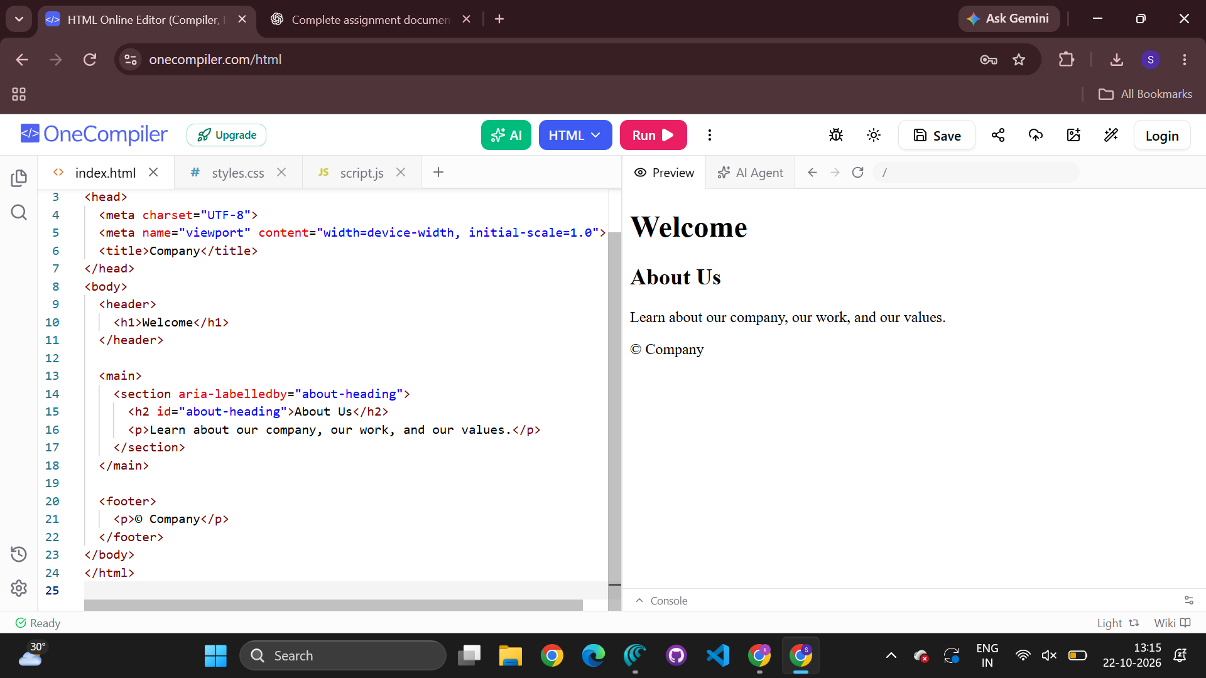
5. Suggest techniques to ensure cross-browser compatibility.
Use valid HTML5 and CSS, declare the doctype, and validate markup with the W3C Markup Validation Service. Use a consistent CSS reset or carefully chosen baseline styles, responsive layouts, and feature detection where necessary. Avoid browser-specific behaviour unless it is supported with suitable fallbacks. Test on major browsers and different screen sizes, use accessible semantic HTML, and check developer-console errors. Keep HTML, CSS, and JavaScript standards-based and use progressive enhancement so core content remains available when a feature is unsupported.

3. Form Submission Failure
Scenario: A login form does not send its data to the server. The form uses GET and its button is configured with type="button".
1. Identify issues in the form configuration.
The main issue is <button type="button">: this creates a button that has no default form-submission behaviour. The form also uses GET for a password field. GET places successful form controls in the URL query string, which is inappropriate for passwords because URLs can be stored in browser history, server logs, and other records. The fields have names, so they can be submitted when a submission is triggered, but the password should not be sent using GET.
2. Analyze why the HTTP request is not triggered.
Clicking a button whose type is button does not submit its enclosing form by default. Unless JavaScript explicitly handles the click and sends a request, the browser will not perform the form's normal submission. Setting the button to type="submit" triggers the browser's form submission process, subject to validation and any JavaScript that may prevent submission.
3. Interpret the role of GET method in this scenario.
GET requests are primarily intended to retrieve a resource. For a standard HTML form, the browser appends successful control names and values to the action URL as a query string. This can be useful for non-sensitive searches or filters, but it is unsuitable for credentials. GET does not provide confidentiality, and query strings may be exposed through browser history, logs, or referrer information. Changing the method to POST avoids putting the credentials in the URL, but HTTPS is still necessary to encrypt them in transit.
4. Propose a corrected implementation.
Use POST, give the button the submit type, associate labels with the inputs, and require the username and password. The server must authenticate the credentials and return an appropriate response.

<!DOCTYPE html>
<html lang="en">
<head>
<meta charset="UTF-8">
<meta name="viewport" content="width=device-width, initial-scale=1.0">
<title>Login</title>
</head>
<body>
<main>
<h1>Login</h1>
<form action="/submit" method="post">
<label for="username">Username:</label>
<input type="text" id="username" name="username" required>

<label for="password">Password:</label>
<input type="password" id="password" name="password" required>

<button type="submit">Login</button>
</form>
</main>
</body>
</html>

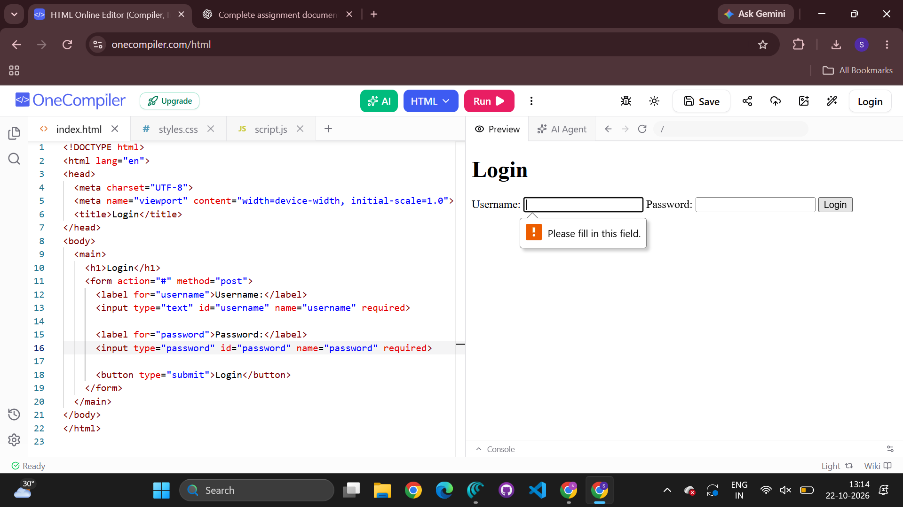
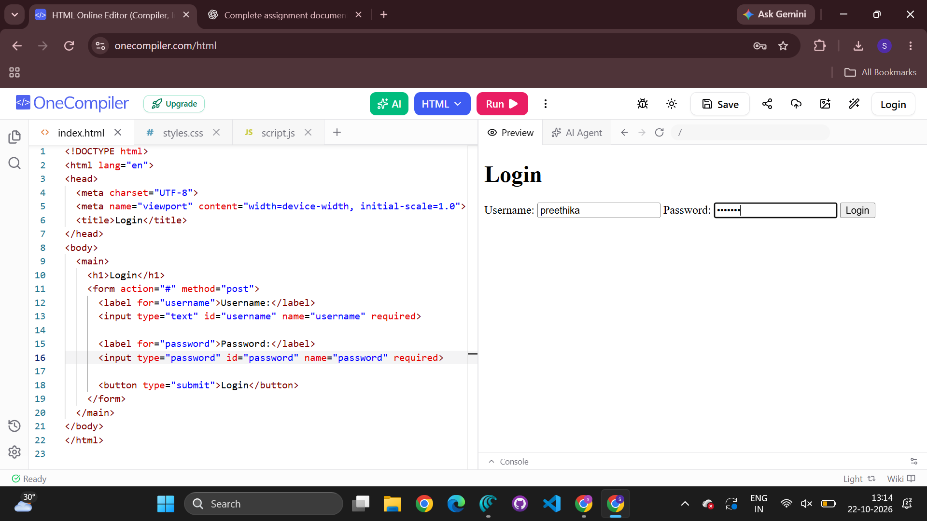
5. Suggest improvements for secure data transmission.
Serve the login page and process credentials only over HTTPS so data is encrypted in transit. Use POST rather than GET for credentials, and never store passwords in plain text; verify them on the server using a suitable salted password-hashing algorithm. Validate inputs on the server, apply rate limiting and protections against brute-force attempts, and use secure session handling with HttpOnly, Secure, and appropriate SameSite cookie attributes. Avoid exposing credentials in logs or error messages, use CSRF protection where applicable, and return clear but non-revealing authentication errors. Client-side validation improves usability but does not replace server-side security.

Code of Conduct
I N. Sai Preethika/192372344 (Name / Register Number) certify that this submission is my original work and that I have adhered to the guidelines specified for this assessment. I understand that any violation of academic integrity rules will result in disciplinary action.
Signature of the student: preethika

